Basic Model

This is a model we did in Python which IBM Decision Optimization CPLEX Modelling from the docplex library. To start with the model, we first import the libraries required for us to run the model.

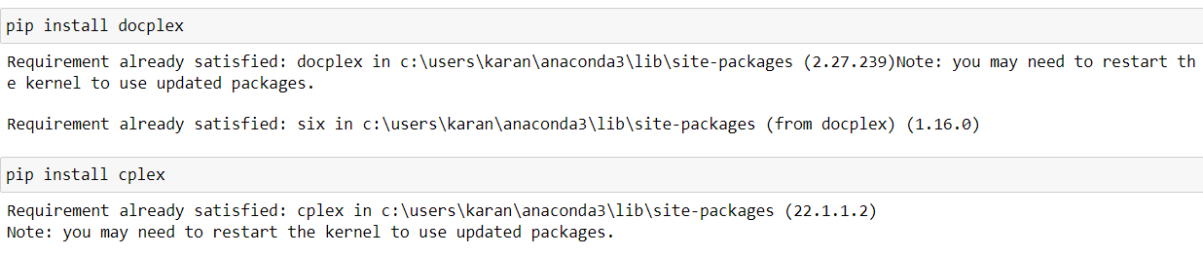

The document has various variables to be defined at first which can be listed below-

1. **Costs**: Details on the expenses incurred in processing crude oil and the cost of purchasing different types of crude oil.
2. **Prices**: The selling prices of various products derived from crude oil.
3. **Capacities**: Maximum production limits at each refinery location, providing insight into the scale of operations.
4. **Monthly Supply Quotas**: Limits on how much of each type of crude oil can be purchased in a month, ensuring balanced procurement.
5. **Demands**: Quantifies the demand for each product across different regions, indicating market needs.

Our project's objective is to put this data to create an approach which will optimize profit while supplying demand, sustaining capacity for production, and upholding purchasing limits. Making judgements involve calculating exactly the most appropriate quantities of crude oil to purchase and the amount of each product each refinery can generate.

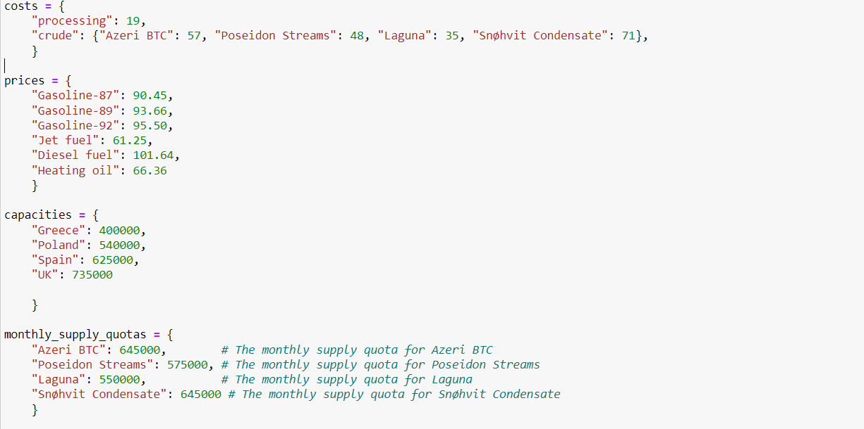

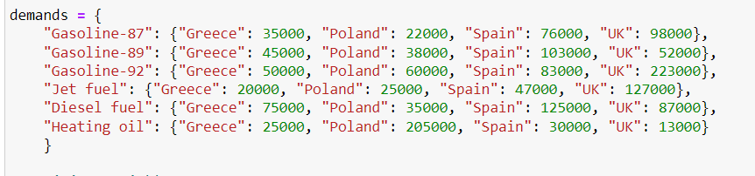

Our purchase and manufacturing approaches to crude oil products are heavily influenced by the selection variables in our optimisation model. The first collection of variables are the purchase variables, which represent the different quantities of crude oil forms we are able to purchase. Since these variables are adaptable, we can change our purchasing approach depending on to demand and cost considerations. Then there is the production variable, which shows us how much we may produce at every refinery location of each product. Considering them to be our levers of modifying production to limitations in capacity and market demand.



Our guiding principle in our optimization model is to maximize profit, which can be expressed by the objective function. For this, we took into account a number of factors. First, we multiply the cost of each product by the number of units that is produced at each refinery to figure out the revenue which generates from exporting it. This gives us with a projection of the profits from sales. We next calculate for all the associated costs. We estimate the total expense of purchasing crude oil through multiplying the amount purchased by the cost per unit of each type of crude oil. In addition, we multiply the processing cost per unit by the production volume to figure out the cost of production spent at every refinery.



Now, we defined the constraints for our model which can be explained below-

1. We made sure that each product's production either meets or exceeds local demand. It also means that each product should be produced in sufficient amounts in each region to satisfy the demand that is specific to that region.
2. We make sure that no refinery's output exceeds its capacity. We can't afford to overburden any refinery beyond what is technically reasonable under this constraint.
3. We enforce a 1:1 ratio among the cost of purchasing and consumption of crude oil. This ensures that the total quantity of crude oil used for all products and regions is equivalent to the quantity of crude oil purchased.
4. We meet every variety of crude oil's monthly supply quota. This limit ensures  that we avoid purchasing more crude oil than we must purchase each month so as to meet our set supply quota.

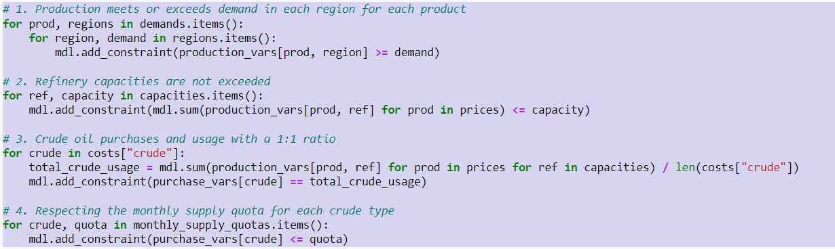

This part of code develops and resolves the optimization model, subsequently evaluates that a solution was found. It gets and prints the responses if there is an answer. The profit achieved is expressed by the objective value, that is shown. The quantity purchased is then printed for each type of oil that was purchased. It additionally displays the overall amount of every product generated at every refinery. The values provided show the ideal production and purchase schedule and are discovered by the optimization model. If, on the other hand, no viable solution is found, it merely produces a message to that extent. By this procedure, we are able to evaluate and understand the best choices given by the optimization model, providing insightful information for making decisions regarding the production and processing of oil.

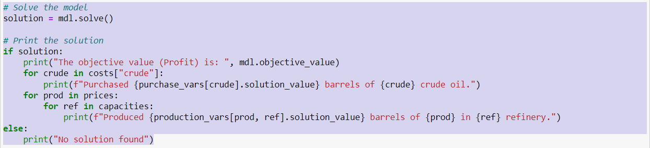

The output would be as follows-

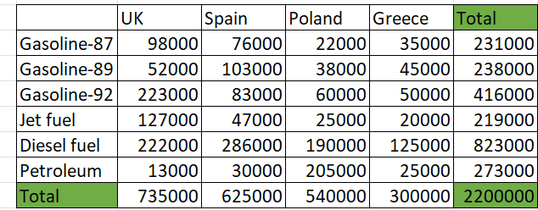

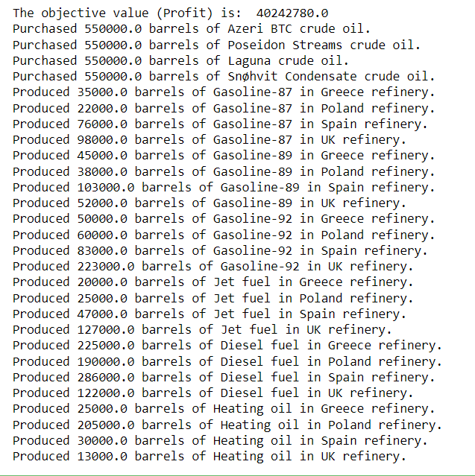

Output Analysis

An analysis of the refinery output reveals several interesting aspects. Firstly, refineries in the UK and Spain boast the highest production capacity, as evidenced by their maximum barrel output. From a profit perspective, diesel appears to be the most produced oil type, potentially signifying greater profitability, followed closely by Gasoline-92. Furthermore, three refineries are operating at full capacity, demonstrating efficient utilization of resources. However, Greece's production falls short of the maximum capacity by 100,000 barrels, suggesting underutilization or potential constraints. The absence of excess production also implies effective inventory management, as the 7% discount scenario wouldn't be applicable.